Borrow Buddy Campus – Campus Item Borrowing Management System
A PROJECT REPORT
Submitted by
Keertana A S
(240701252)
in partial fulfilment of the End Semester Examination for the course
CB23F35 –
LOW-CODE APPLICATION DEVELOPEMENT USING ZOHO CREATOR
in
Bachelor of Engineering
Computer Science Engineering

RAJALAKSHMI ENGINEERING COLLEGE
(An Autonomous Institution, Affiliated to Anna University, Chennai)
Rajalakshmi Nagar, Thandalam, Tamil Nadu – 602 105
NOVEMBER 2026

(An Autonomous Institution, Affiliated to Anna University, Chennai)
BONAFIDE CERTIFICATE
Certified that this project report titled “Borrow Buddy Campus – Campus Item Borrowing Management System” is the bonafide work of Keertana A S (240701252), who carried out the individual project work on the Zoho Creator low-code platform for the course CB23F35 – Low-Code Application Development using Zoho Creator, during the academic year [2026–2027], Semester [V], under my supervision.
SIGNATURE  HEAD OF THE DEPARTMENT  Department of CSE  Rajalakshmi Engineering College  Thandalam – 602 105 | SIGNATURE  COURSE FACULTY  Department of CSE  Rajalakshmi Engineering College

Submitted for the End Semester Examination (Individual Project) held on [10 NOVEMBER 2026].
INTERNAL EXAMINER | EXTERNAL EXAMINER

DECLARATION
I, Keertana A S (240701252), hereby declare that the project report titled “BORROW BUDDY CAMPUS – CAMPUS ITEM BORROWING MANAGEMENT SYSTEM”, submitted for the End Semester Examination of the course CB23F35 – Low-Code Application Development using Zoho Creator, is a record of original work carried out by me individually. The Zoho Creator application described in this report was designed and developed by me with the use of the platform’s application-building features and Deluge scripting.
I further declare that this work has not been submitted, in part or in full, for the award of any other degree or course credit. Every template, sample application, AI-assisted feature (such as Zia or the AI application builder), code snippet or external resource used in this work has been duly acknowledged in the report.
Place: Chennai SIGNATURE OF THE STUDENT
Date: [10 November 2026] KEERTANA A S
240701252

ACKNOWLEDGEMENT

I express my sincere gratitude to the management of Rajalakshmi Engineering College for providing the infrastructure and facilities required to complete this project.
I am grateful to the Principal of Rajalakshmi Engineering College for the encouragement extended to students to undertake practical and industry-relevant learning.
I thank the Head of the Department, Department of Computer Science and Engineering, for the support provided throughout the course.
I owe my sincere thanks to my course faculty, Dr. Jinu Sophia, for the valuable guidance, reviews and feedback that helped me develop this application and prepare this report.
I also acknowledge Zoho Corporation for providing the Zoho Creator platform and learning resources. I thank my family and friends for their encouragement and support.

KEERTANA A S

ABSTRACT

Borrowing essential items within a college campus is often handled through informal conversations, paper records or separate spreadsheets. This can make it difficult for students to know which items are available, where to request them and when they must be returned. Coordinators may also find it difficult to maintain accurate records of borrowers, item availability and request status. Borrow Buddy Campus addresses this problem in the educational domain by providing a centralised application for managing short-term borrowing of commonly needed campus items.
The application was developed using Zoho Creator. It contains Student Registration, Item Registration, Borrowing Request, Return Tracking and Borrowing Feedback forms, together with reports and a dashboard. Students can be registered, campus items can be catalogued, and borrowing requests can be recorded and reviewed. A borrowing request follows a lifecycle represented by Pending, Approved, Borrowed, Returned or Rejected states. A Blueprint named Borrowing_Request_Process represents the request lifecycle, and an approval workflow named Borrowing_Request_Approval routes requests to the Student Peer Coordinator. Deluge functions support request identification, student validation, item availability checks, status handling, return-day calculation, availability updates, feedback rating calculation, overdue checks and emergency email logic. A return-tracking workflow was tested and updated the related item’s availability to Available.
The application was tested using sample student, item, borrowing-request and return records. The dashboard displayed summary counts and request-distribution charts, while the return workflow was verified by adding a return record and checking that the corresponding item became Available. Role and portal permission settings were configured in the application. External service integrations and the AI urgency classifier were not treated as completed integrations because their connection and execution were not verified. The project demonstrates how a low-code platform can centralise campus borrowing records and automate selected parts of the borrowing and return process.
Keywords: Low-Code Development; Zoho Creator; Campus Borrowing; Deluge Scripting; Workflow Automation; Item Inventory Management.

PROJECT AT A GLANCE

Attribute | Details
Project Title | Borrow Buddy Campus – Campus Item Borrowing Management System
Application Domain | Education / Campus Resource Management
Student Name & Register No. | Keertana A S – 240701252
Zoho Creator Edition | Trial environment (edition label to be confirmed)
Application Name (Link Name) | Borrow Buddy Campus (borrow-buddy-campus)
Published / Live URL | Development application; public production URL not verified
Demo Credentials (per role) | Not included in report for security; create examiner demo accounts if required
Number of Forms / Subforms | 5 forms / subform not confirmed
Number of Reports (by type) | List: All Requests and form reports; Charts: requester and request-status distribution; other types not confirmed
Number of Pages / Dashboards | 1 dashboard
Number of Workflows | Form workflows: configured; Approval: 1; Blueprint: 1; Schedules: not verified; Batch: not verified
Deluge Functions / Custom Actions | 10 functions created; individual end-to-end verification incomplete
Integrations | Zoho Mail, Cliq and Calendar connections not configured/verified
Roles & Profiles Defined | Administrator hierarchy, Student Peer Coordinator, Student Borrower; portal permissions reviewed
Environments Used | Development environment; production deployment not verified
Date of Production Deployment | Not deployed / not verified

TABLE OF CONTENTS
ABSTRACT i
PROJECT AT A GLANCE i
LIST OF TABLES i
LIST OF FIGURES i
LIST OF ABBREVIATIONS i
INTRODUCTION 1
1.1 Background 1
1.2 Problem Statement 1
1.3 Objectives 1
1.4 Scope of the Project 1
1.5 Justification for a Low-Code Approach 1
1.6 Organisation of the Report 1
LITERATURE SURVEY AND SYSTEM STUDY 1
2.1 Study of the Existing System 1
2.2 Limitations of the Existing System 1
2.3 Low-Code versus Traditional Development 1
2.4 Literature Survey 1
2.5 Emerging Trends in Low-Code Development 1
2.6 Proposed System 1
REQUIREMENT ANALYSIS 1
3.1 Stakeholders and User Roles 1
3.2 Functional Requirements 1
3.3 Non-Functional Requirements 1
3.4 Hardware and Software Requirements 1
3.5 Use Case Model 1
SYSTEM DESIGN 1
4.1 System Architecture 1
4.2 Data Model 1
4.3 Form Design 1
4.4 Process and Workflow Design 1
4.5 User Interface and Navigation Design 1
4.6 Access Control Design 1
IMPLEMENTATION 1
5.1 Application Setup 1
5.2 Forms and Data Capture 1
5.3 Reports 1
5.4 Pages and Dashboards 1
5.5 Deluge Scripting 1
5.6 Workflows and Automation 1
5.7 Integrations 1
5.8 User Management and Role-Based Access 1
5.9 AI and Analytics Features 1
5.10 Pro-Code Extension 1
5.11 Mobile and Portal Access 1
TESTING AND DEBUGGING 1
6.1 Testing Strategy 1
6.2 Test Cases 1
6.3 Debugging Deluge Scripts 1
6.4 Defect Log 1
6.5 User Acceptance Testing 1
DEPLOYMENT, SECURITY AND GOVERNANCE 1
7.1 Environments and Deployment Strategy 1
7.2 Performance Optimisation 1
7.3 Security Features 1
7.4 Governance and Administration 1
RESULTS AND DISCUSSION 1
8.1 Application Output 1
8.2 Achievement of Objectives 1
8.3 Comparison with the Existing System 1
8.4 Limitations of the Low-Code Approach 1
8.5 Reflection on the No-Code → Low-Code → Pro-Code Spectrum 1
CONCLUSION AND FUTURE ENHANCEMENTS 1
9.1 Conclusion 1
9.2 Future Enhancements 1
9.3 Learning Outcomes and Career Relevance 1
REFERENCES 1
APPENDIX A – ZOHO CREATOR FEATURE COVERAGE CHECKLIST 1
APPENDIX B – COURSE OUTCOME MAPPING 1
APPENDIX C – COMPLETE DELUGE SOURCE CODE 1
APPENDIX D – USER MANUAL 1
D.1 Accessing the Application 1
D.2 Instructions for Student Borrower 1
D.3 Instructions for Student Peer Coordinator 1
APPENDIX E – EVALUATION RUBRIC 1
APPENDIX F – VIVA-VOCE RECORD SHEET 1

ABSTRACT i
PROJECT AT A GLANCE i
LIST OF TABLES i
LIST OF FIGURES i
LIST OF ABBREVIATIONS i
INTRODUCTION 1
1.1 Background 1
1.2 Problem Statement 1
1.3 Objectives 1
1.4 Scope of the Project 1
1.5 Justification for a Low-Code Approach 1
1.6 Organisation of the Report 1
LITERATURE SURVEY AND SYSTEM STUDY 1
2.1 Study of the Existing System 1
2.2 Limitations of the Existing System 1
2.3 Low-Code versus Traditional Development 1
2.4 Literature Survey 1
2.5 Emerging Trends in Low-Code Development 1
2.6 Proposed System 1
REQUIREMENT ANALYSIS 1
3.1 Stakeholders and User Roles 1
3.2 Functional Requirements 1
3.3 Non-Functional Requirements 1
3.4 Hardware and Software Requirements 1
3.5 Use Case Model 1
SYSTEM DESIGN 1
4.1 System Architecture 1
4.2 Data Model 1
4.3 Form Design 1
4.4 Process and Workflow Design 1
4.5 User Interface and Navigation Design 1
4.6 Access Control Design 1
IMPLEMENTATION 1
5.1 Application Setup 1
5.2 Forms and Data Capture 1
5.3 Reports 1
5.4 Pages and Dashboards 1
5.5 Deluge Scripting 1
5.6 Workflows and Automation 1
5.7 Integrations 1
5.8 User Management and Role-Based Access 1
5.9 AI and Analytics Features 1
5.10 Pro-Code Extension 1
5.11 Mobile and Portal Access 1
TESTING AND DEBUGGING 1
6.1 Testing Strategy 1
6.2 Test Cases 1
6.3 Debugging Deluge Scripts 1
6.4 Defect Log 1
6.5 User Acceptance Testing 1
DEPLOYMENT, SECURITY AND GOVERNANCE 1
7.1 Environments and Deployment Strategy 1
7.2 Performance Optimisation 1
7.3 Security Features 1
7.4 Governance and Administration 1
RESULTS AND DISCUSSION 1
8.1 Application Output 1
8.2 Achievement of Objectives 1
8.3 Comparison with the Existing System 1
8.4 Limitations of the Low-Code Approach 1
8.5 Reflection on the No-Code → Low-Code → Pro-Code Spectrum 1
CONCLUSION AND FUTURE ENHANCEMENTS 1
9.1 Conclusion 1
9.2 Future Enhancements 1
9.3 Learning Outcomes and Career Relevance 1
REFERENCES 1
APPENDIX A – ZOHO CREATOR FEATURE COVERAGE CHECKLIST 1
APPENDIX B – COURSE OUTCOME MAPPING 1
APPENDIX C – COMPLETE DELUGE SOURCE CODE 1
APPENDIX D – USER MANUAL 1
D.1 Accessing the Application 1
D.2 Instructions for Student Borrower 1
D.3 Instructions for Student Peer Coordinator 1
APPENDIX E – EVALUATION RUBRIC 1
APPENDIX F – VIVA-VOCE RECORD SHEET 1

LIST OF TABLES
Table 2.1: Comparison of Low-Code and Traditional Development for the Proposed Application 3
Table 2.2: Summary of Literature Survey 4
Table 3.1: Stakeholders and User Roles 5
Table 3.2: Functional Requirements 5
Table 3.3: Non-Functional Requirements 5
Table 3.4: Hardware and Software Requirements 6
Table 3.5: Use Case Description – [Use Case Name] 6
Table 4.1: Entities and Relationships 9
Table 4.2: Field Specification – [Form Name] Form 9
Table 4.3: Role–Permission Matrix 10
Table 5.1: Reports Implemented 12
Table 5.2: Deluge Scripts Implemented 13
Table 5.3: Workflows Implemented 14
Table 5.4: Integrations Implemented 15
Table 6.1: Test Cases 18
Table 6.2: Defect Log 19
Table 6.3: User Acceptance Feedback 19
Table 7.1: Deployment Checklist 20
Table 7.2: Performance Optimisation Results 20
Table 7.3: Security Controls Implemented 21
Table 8.1: Mapping of Objectives to Outcomes 23
Table 8.2: Existing System versus Proposed Application 23
Table A.1: Feature Coverage Checklist 26
Table B.1: Mapping of Course Outcomes to Report Chapters 28
Table E.1: Evaluation Rubric for the Individual Project 31
Table E.2: Performance Level Descriptors 32
Table F.1: Viva-Voce Questions and Responses 33
Table F.2: Marks Summary 33

LIST OF ABBREVIATIONS
Abbreviation | Expansion
API | Application Programming Interface
CRUD | Create, Read, Update, Delete
ER | Entity–Relationship
LCAP | Low-Code Application Platform
RBAC | Role-Based Access Control
UI | User Interface
UAT | User Acceptance Testing
Zia | Zoho AI assistant
SDLC | Software Development Life Cycle
SSO | Single Sign-On
UAT | User Acceptance Testing
UI | User Interface
Zia | Zoho’s AI assistant
[ ] | [ ]

CHAPTER 1

INTRODUCTION

1.1 Background

Borrow Buddy Campus is a campus resource-sharing application designed for a college environment. Students sometimes require short-term access to essential items such as calculators, chargers, umbrellas, lab coats and books. These items may be available from a peer coordinator or a campus resource desk, but the request and return process can become difficult to track when it is managed through informal messages or paper-based records. The application provides one place to register students, maintain an item catalogue, record borrowing requests, monitor returns and collect feedback. The main users are student borrowers, student peer coordinators and application administrators.

1.2 Problem Statement

Students need a simple and traceable way to request temporary use of campus items. Without a centralised record, item availability may not be current, requests may be overlooked, and return dates may not be monitored consistently. Borrow Buddy Campus provides structured forms, request status tracking, approval configuration and return tracking to improve visibility and accountability.
- Borrowing requests and student details may otherwise be scattered across messages or separate records.
- Item availability can become inaccurate if borrowing and return events are not updated consistently.
- Coordinators may lack a single dashboard to monitor requests, returns and feedback.

1.3 Objectives

- To create structured forms for student registration, item registration, borrowing requests, return tracking and feedback.
- To use Deluge functions and workflows for validation, item availability checks, request handling and return updates.
- To provide reports and a dashboard for viewing request status, item registrations, student registrations and return records.
- To configure approval and Blueprint-based request lifecycle management for coordinator review.
- To define user roles and portal permissions and document security and deployment considerations.

1.4 Scope of the Project

The project covers student registration, item catalogue management, borrowing request submission, request approval, request status tracking, return recording, item availability updates, feedback collection and dashboard reporting. The configured roles include Student Borrower, Student Peer Coordinator and administrative users. The application was built in Zoho Creator and accessed through its web-based builder and application interface. Full external integrations, a deployed customer portal and a verified AI urgency model are outside the implemented scope of this version.

1.5 Justification for a Low-Code Approach

Zoho Creator is suitable for this project because it provides visual form and report builders, workflow configuration, role and permission settings, and Deluge scripting within one platform. The application requires related data-entry forms and repeatable status-based processes rather than a large custom software stack. A low-code approach reduces the amount of infrastructure and interface code that must be developed manually, while allowing custom logic to be added where needed. Zoho Creator documentation describes the platform’s form, report, workflow and scripting capabilities [1]–[3].

1.6 Organisation of the Report
Chapter 2 reviews the existing process and the proposed low-code solution. Chapter 3 presents the requirements and user roles. Chapter 4 describes the system architecture, data model, forms, workflows and access control. Chapter 5 explains the implementation. Chapter 6 discusses testing and debugging. Chapter 7 describes deployment, security and governance. Chapter 8 presents the results and limitations, and Chapter 9 concludes the report and identifies future enhancements.
CHAPTER 2

LITERATURE SURVEY AND SYSTEM STUDY

2.1 Study of the Existing System

In a typical informal campus borrowing process, a student contacts a coordinator to ask whether an item is available. The coordinator checks the item physically or through a personal record, collects the student’s details, and decides whether the item can be issued. The borrowing and expected return details may be written in a notebook or spreadsheet. When the item is returned, the coordinator manually updates the record and informs the next student if the item is available. Feedback is usually collected informally, if at all.

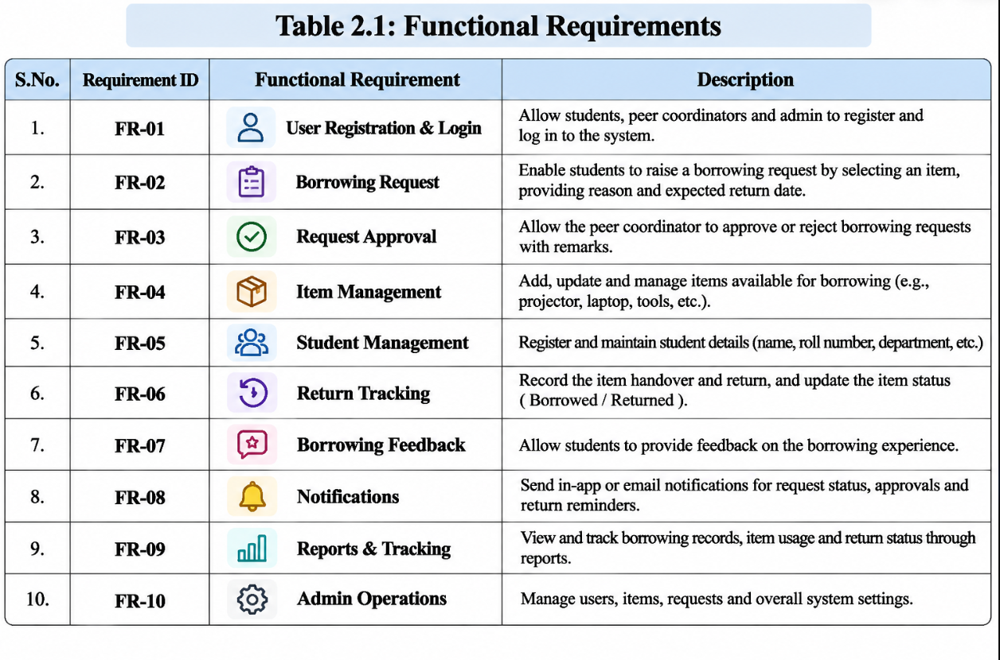.
Figure 2.1: Existing Campus Borrowing Process

2.2 Limitations of the Existing System
- Requests may be recorded in multiple places, making information difficult to consolidate.
- Availability information may not be updated immediately after issue or return.
- There may be no centralised request history, overdue visibility or feedback summary.

2.3 Low-Code versus Traditional Development

Table 2.1: Comparison of Low-Code and Traditional Development for the Proposed Application
Criterion | Traditional (Pro-Code) Development | Low-Code on Zoho Creator
Development time | [e.g., 8–10 weeks] | [e.g., 2–3 weeks]
Skills required | [ ] | [ ]
Hosting & infrastructure | [ ] | [ ]
Mobile application | [ ] | [ ]
Security & access control | [ ] | [ ]
Maintenance & change | [ ] | [ ]
Customisation limits | [ ] | [ ]
Cost | [ ] | [ ]

2.4 Literature Survey

Table 2.2: Summary of Literature Survey
S.No. | Author(s) / Source & Year | Title / Product | Key Findings | Relevance to this Project
1 | [ ] | [ ] | [ ] | [ ]
2 | [ ] | [ ] | [ ] | [ ]
3 | [ ] | [ ] | [ ] | [ ]
4 | [ ] | [ ] | [ ] | [ ]
5 | [ ] | [ ] | [ ] | [ ]

2.5 Emerging Trends in Low-Code Development

Low-code development allows forms, reports and workflows to be assembled through a visual environment, while Deluge provides custom logic for validation and record updates. AI-assisted application building can accelerate the initial creation of forms and reports, but the generated output must still be checked and configured. Workflow automation reduces repeated manual actions, and role-based configuration helps organise access for borrowers and coordinators. In this project, the application builder was used to create the initial structure, followed by manual configuration of functions, workflows, Blueprint and approval settings.

2.6 Proposed System

Borrow Buddy Campus is a centralised Zoho Creator application for managing campus item borrowing. It stores student and item details, captures borrowing requests, supports coordinator approval, records returns and collects feedback. Its dashboard presents summary counts and request-distribution charts. Deluge functions and workflows support selected validation and item-availability operations. Compared with the informal process, the proposed system provides structured records and a clearer request lifecycle.
CHAPTER 3

REQUIREMENT ANALYSIS

3.1 Stakeholders and User Roles
Table 3.1: Stakeholders and User Roles
Role | Description | Key Responsibilities in the Application
Administrator | Application owner and configuration user | Manage application settings, users, roles, permissions and all records
Student Peer Coordinator | Student coordinator responsible for campus item circulation | Review requests, approve/reject requests, manage item availability, track returns and review feedback
Student Borrower | Student who needs to borrow a campus item | Register, submit borrowing requests, view request status, return items and provide feedback
Portal User | Portal permission category configured for external users | Portal access is configured at permission level; complete portal login journey not verified

3.2 Functional Requirements

Table 3.2: Functional Requirements
FR ID | Requirement | Role(s) | Priority
FR-01 | The system shall store student registration details. | Student Borrower, Administrator | High
FR-02 | The system shall maintain an item catalogue and availability status. | Coordinator, Administrator | High
FR-03 | The system shall capture borrowing requests linked to a student and an item. | Student Borrower | High
FR-04 | The system shall support approval or rejection of borrowing requests. | Student Peer Coordinator | High
FR-05 | The system shall record item returns and update item availability to Available. | Coordinator | High
FR-06 | The system shall display summary counts and request distribution on a dashboard. | Coordinator, Administrator | Medium
FR-07 | The system shall collect borrowing feedback and ratings. | Student Borrower | Medium

3.3 Non-Functional Requirements
Table 3.3: Non-Functional Requirements
NFR ID | Category | Requirement
NFR-01 | Performance | Forms and reports should load within a reasonable time for the expected campus record volume.
NFR-02 | Security | Users should access only the modules and records permitted by their assigned role.
NFR-03 | Usability | Forms and reports should use clear labels and a consistent navigation structure.
NFR-04 | Availability | The application depends on Zoho Creator service availability and internet connectivity.
NFR-05 | Maintainability | Forms, workflows and functions should use consistent names and documented logic.
NFR-06 | Auditability | Record changes should be reviewed using the platform’s available history and administration features.

3.4 Hardware and Software Requirements
Table 3.4: Hardware and Software Requirements
Category | Specification
Platform | Zoho Creator (trial environment)
Scripting language | Deluge
Browser | Google Chrome
API testing tool | Not used in the implemented version
Other Zoho services | Zoho Mail, Cliq and Calendar proposed; connections not verified
Mobile | Mobile application access not demonstrated
Client hardware | Windows 11 laptop, modern web browser and internet connection

3.5 Use Case Model

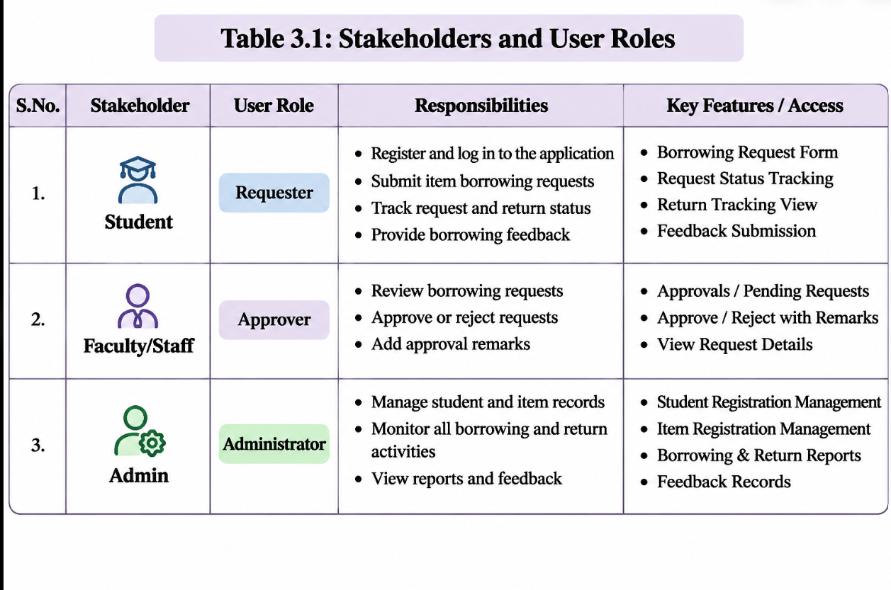
Figure 3.1: Use Case Diagram of Borrow Buddy Campus
Table 3.5: Use Case Description – [Use Case Name]
Use Case ID | UC-01
Use Case Name | Submit and process a borrowing request
Actor(s) | Student Borrower; Student Peer Coordinator
Pre-condition | Student and item records exist in the application.
Main Flow | 1. Student opens Borrowing Request. 2. Student selects the requested item. 3. Request is submitted with Pending status. 4. Coordinator reviews and approves or rejects it.
Alternate Flow | Coordinator rejects the request; request moves to Rejected and is not issued.
Post-condition | Request is stored with its current status for tracking.
Related FR | FR-02, FR-03, FR-04
CHAPTER 4

SYSTEM DESIGN

4.1 System Architecture

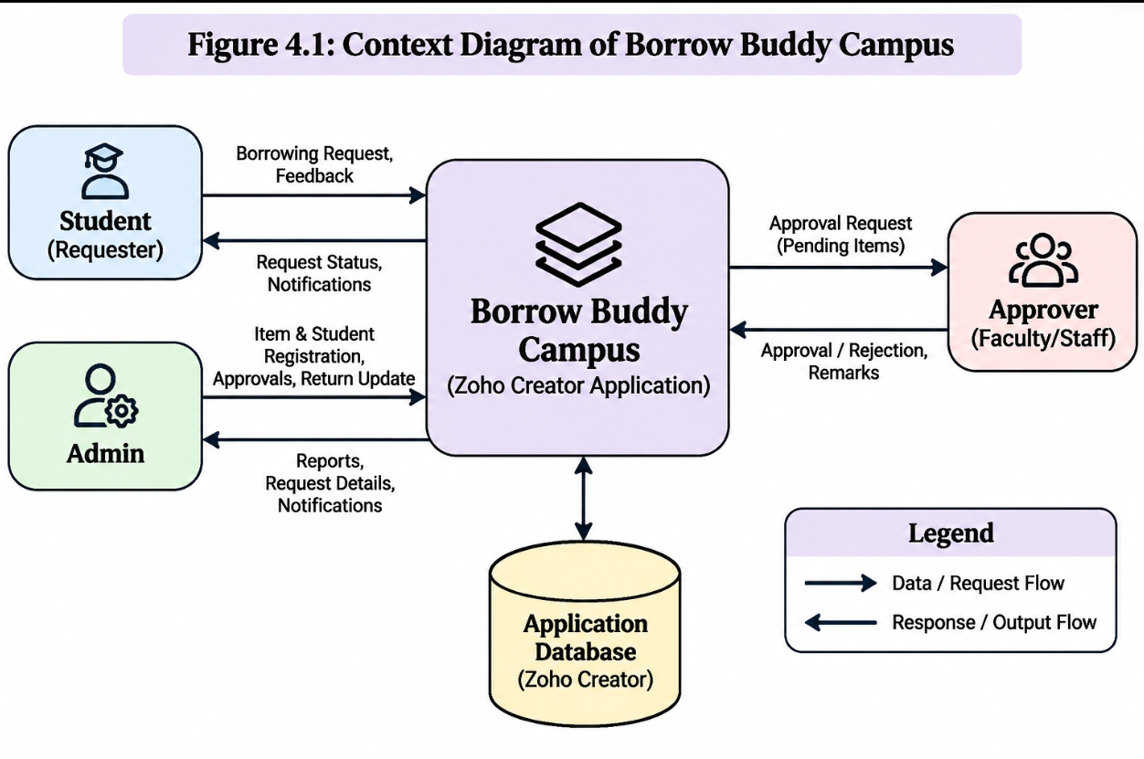
Figure 4.1: System Architecture of Borrow Buddy Campus
The application follows a layered architecture. Student borrowers and student peer coordinators interact with the Zoho Creator user interface through forms, reports and the dashboard. The application logic layer contains Deluge functions, form workflows, an approval workflow and a Blueprint. The data layer stores student registrations, item registrations, borrowing requests, return tracking and feedback. The configured return workflow reads the related borrowing request and item record, then changes the item availability to Available when a return record is submitted. External Zoho service connections and AI model execution are not claimed as implemented.

4.2 Data Model

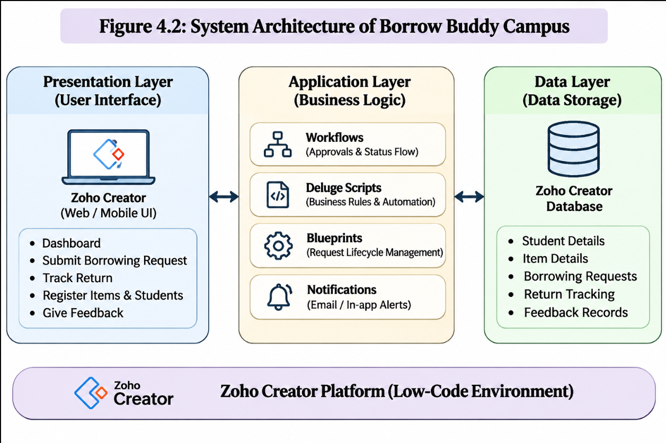
Figure 4.2: Entity–Relationship Diagram of Borrow Buddy Campus
Table 4.1: Entities and Relationships
Entity (Form) | Key Fields | Related To | Relationship Type | Implemented Using
Student Registration | Registration number, student details, email | Borrowing Request | One-to-Many | Requester lookup in Borrowing Request
Item Registration | Item name, availability status | Borrowing Request | One-to-Many | Requested item lookup in Borrowing Request
Borrowing Request | Requester, requested item, request status | Return Tracking | One-to-Many / related record | Borrowing request lookup in Return Tracking

4.3 Form Design

Table 4.2: Field Specification – [Form Name] Form
Field Label | Link Name | Field Type | Mandatory | Validation / Default | Remarks
Registration Number | registration_number | Single Line | Yes | Student registration identifier | Student Registration
Email | email | Email | Yes | Valid email address | Student contact
Item Name | item_name | Single Line | Yes | Item catalogue name | Item Registration
Availability Status | availability_status | Drop Down | Yes | Available / Borrowed / Lost / Under Maintenance / Damaged | Item Registration
Requester | requester | Lookup | Yes | Lookup to student_registration | Borrowing Request

4.4 Process and Workflow Design

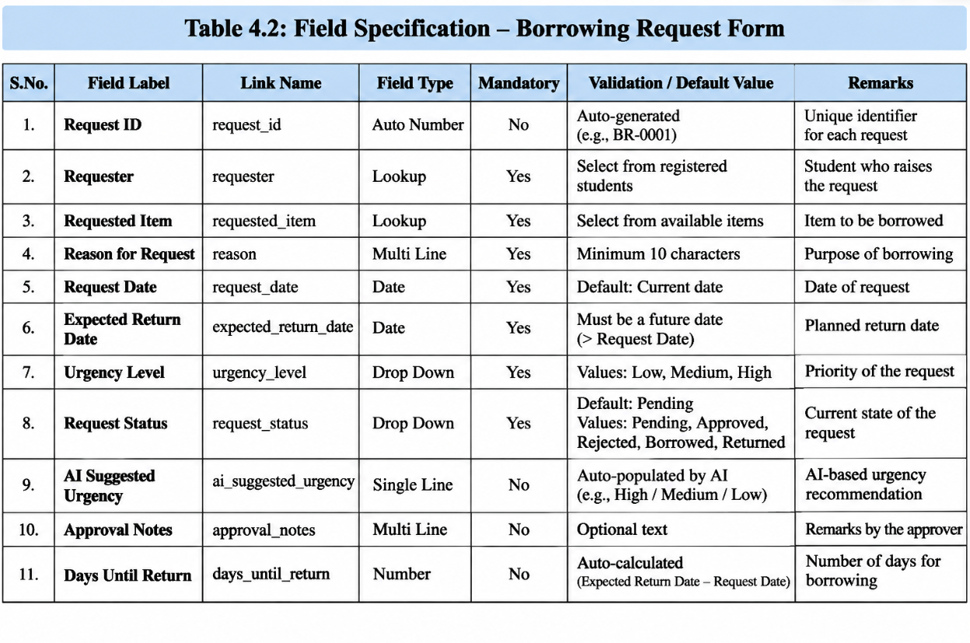
Figure 4.3: Borrowing Request and Return Workflow

4.5 User Interface and Navigation Design

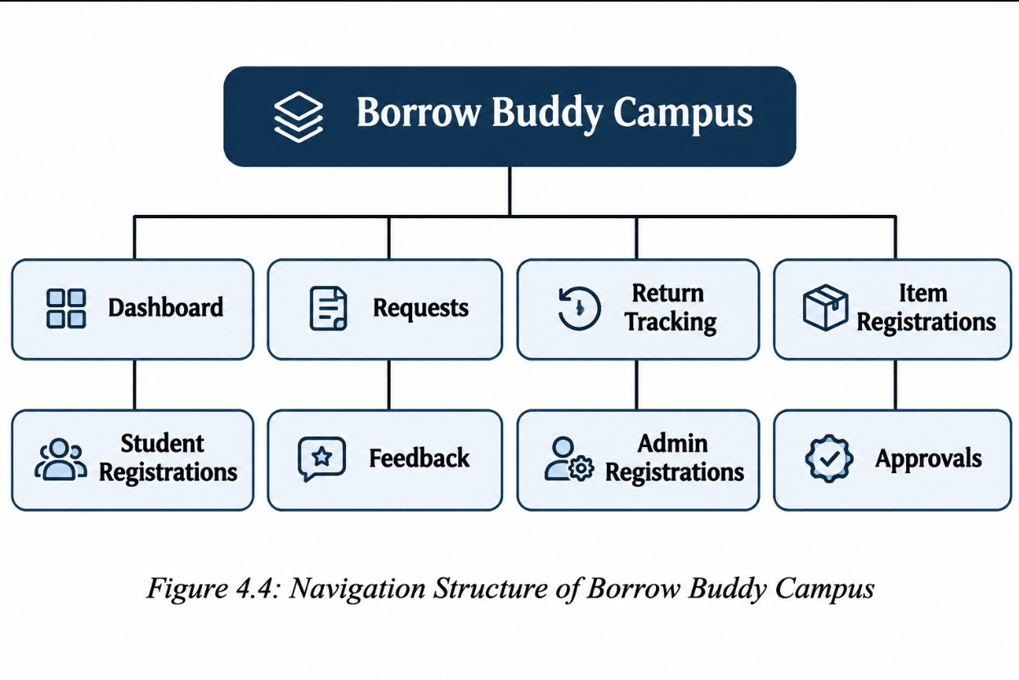
Figure 4.4: Borrow Buddy Campus Navigation Structure

4.6 Access Control Design

Table 4.3: Role–Permission Matrix
Component | Administrator | Student Peer Coordinator | Student Borrower | Portal User
Student Registration | A E V D | V | A V | Not verified
Item Registration | A E V D | A E V | V (catalogue) | Not verified
Borrowing Request | A E V D | A E V | A V (own records intended) | Not verified
Return Tracking | A E V D | A E V | V (own records intended) | Not verified
Dashboard / All Requests | V | V | — | Not verified
CHAPTER 5

IMPLEMENTATION

5.1 Application Setup

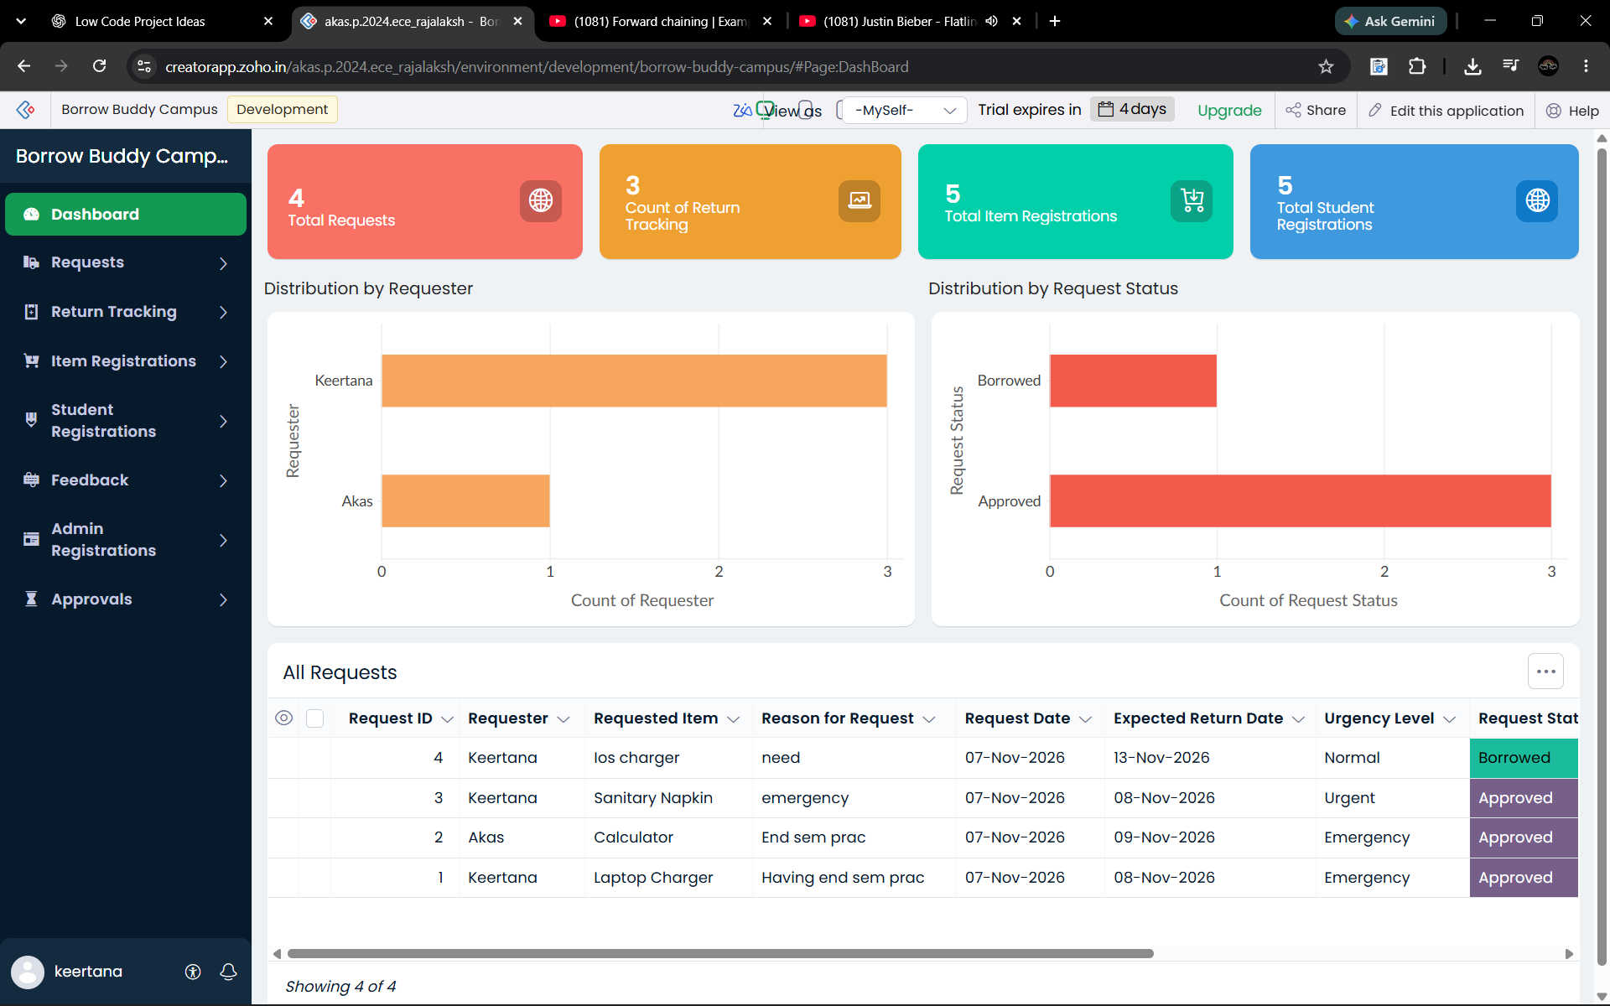
Figure 5.1: Borrow Buddy Campus Application Home and Navigation

5.2 Forms and Data Capture

The application contains five main forms. Student Registration stores borrower details and includes an email field and registration number. Item Registration stores the campus item catalogue and its availability status. Borrowing Request links a requester to a requested item and stores the request status. Return Tracking records the return against a borrowing request. Borrowing Feedback stores feedback and a numeric rating. Lookup fields connect related records so that a return can be associated with the original request and item.

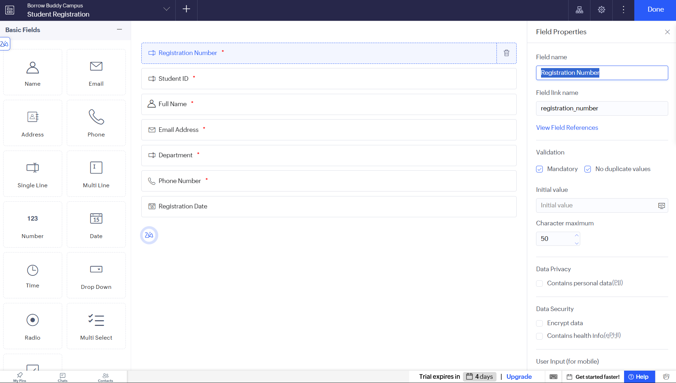
Figure 5.2: Student Registration Form in the Form Builder

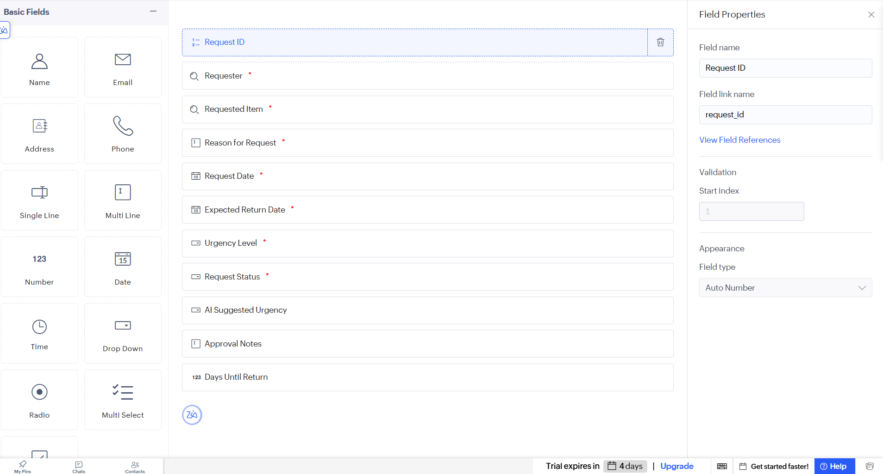
Figure 5.3: Borrowing Request Form in Live Mode

5.3 Reports

Table 5.1: Reports Implemented
Report Name | Type | Source Form | Filter / Grouping / Sorting | Custom Actions | Roles
All Requests | List | Borrowing Request | Request records; status can be reviewed | Status update through report / workflow | Administrator, Coordinator
Student Registrations | List | Student Registration | Student records | — | Administrator, Coordinator
Item Registrations | List | Item Registration | Item catalogue and availability | — | Administrator, Coordinator
Return Tracking | List | Return Tracking | Return records | Return workflow updates availability | Administrator, Coordinator
Dashboard Charts | Chart | Borrowing Request / related forms | Distribution by requester and request status | Quick links | Administrator, Coordinator

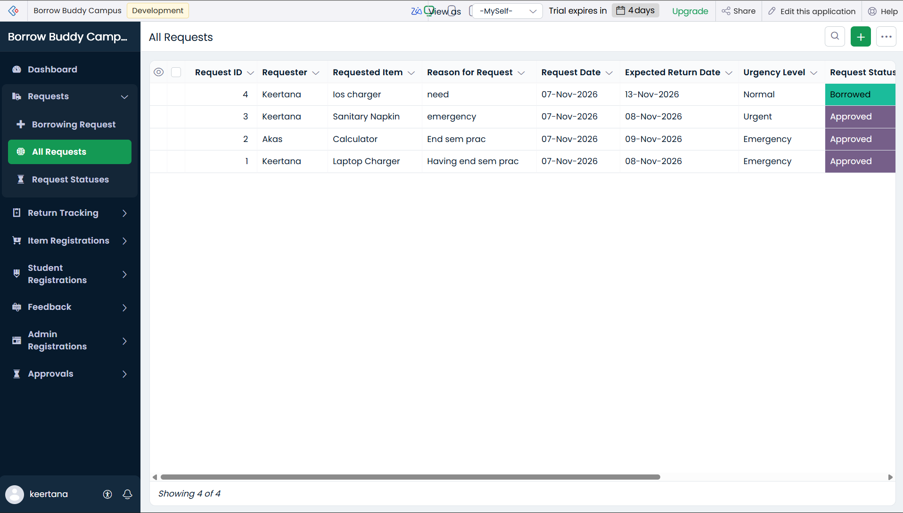
Figure 5.4: All Requests Report

5.4 Pages and Dashboards

The dashboard combines summary values and charts for monitoring the application. The demonstrated dashboard includes counts for borrowing requests, return tracking records, item registrations and student registrations. It also includes an AI Suggested Urgency summary area, a chart showing distribution by requester, a chart showing distribution by request status, quick links and an All Requests report. The presence of the urgency summary area is documented as a dashboard element; a separately configured and verified AI classifier is not claimed.

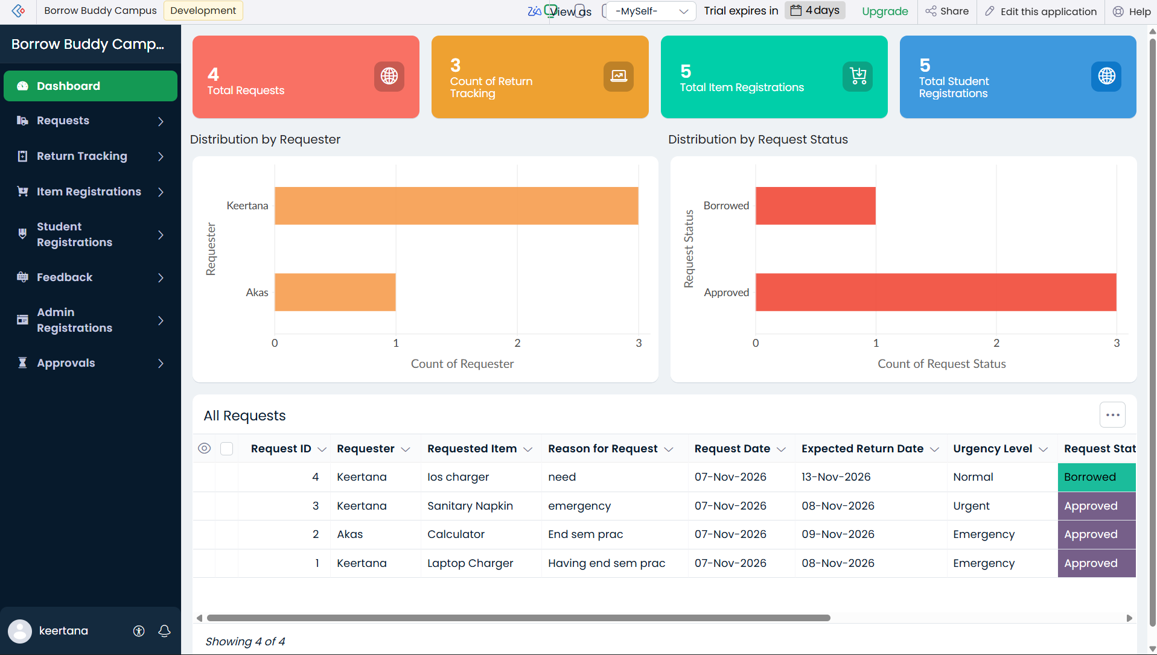
Figure 5.5: Borrow Buddy Campus Dashboard

5.5 Deluge Scripting

Table 5.2: Deluge Scripts Implemented
Script ID | Location / Trigger | Purpose | Deluge Concepts Used
DS-01 | Function: Generate_Request_ID | Generate a unique borrowing request identifier. | Date/time formatting, string construction
DS-02 | Function: Validate_Student | Check whether a student registration exists. | Criteria fetch, conditional logic
DS-03 | Function: Check_Availability | Check whether an item is available. | Criteria fetch, if-else
DS-04 | Function: Set_Pending | Return the Pending status value. | Function return
DS-05 | Function: Calc_Return_Days | Calculate the return duration. | Date functions, date difference

Code 5.1: [Validation script]
// DS-01: Generate_Request_ID
// A unique request identifier was generated using the current date/time.
// Exact production source should be copied from the Zoho Creator function editor.

Code 5.2: [Notification script]
// DS-02: Validate_Student / DS-03: Check_Availability
// Student lookup uses student_registration and registration_number.
// Item lookup uses item_registration, item_name and availability_status.
// Refer to the live Zoho Creator function editor for the complete saved source.

The Deluge functions created for the application cover request ID generation, student validation, item availability checking, pending status handling, return-day calculation, item availability updates after approval and return, average feedback rating calculation, overdue checking and emergency email logic. The functions are listed below. Their existence in the application does not imply that every function was independently verified in a live end-to-end scenario. The return availability update was verified through the Return Tracking workflow.

5.6 Workflows and Automation

Table 5.3: Workflows Implemented
Workflow Name | Type | Trigger / Event | Condition | Action(s) | Script Ref.
New Borrowing Request Notification | Form Workflow | On Add – Borrowing Request | New request submitted | Coordinator notification configured | —
Borrowing Confirmation | Form Workflow | Borrowing Request status update | Status change | Student email action configured; delivery not verified | —
Return Availability Update | Form Workflow | On Add – Return Tracking | Related borrowing request exists | Set linked item availability to Available | Return workflow Deluge
Borrowing_Request_Approval | Approval | On review | New Borrowing Request | Student Peer Coordinator approves or rejects | Approval configuration
Borrowing_Request_Process | Blueprint | Pending → Approved/Rejected → Borrowed → Returned | Lifecycle transitions | Approve Request, Reject Request, Mark as Borrowed, Confirm Return | Blueprint

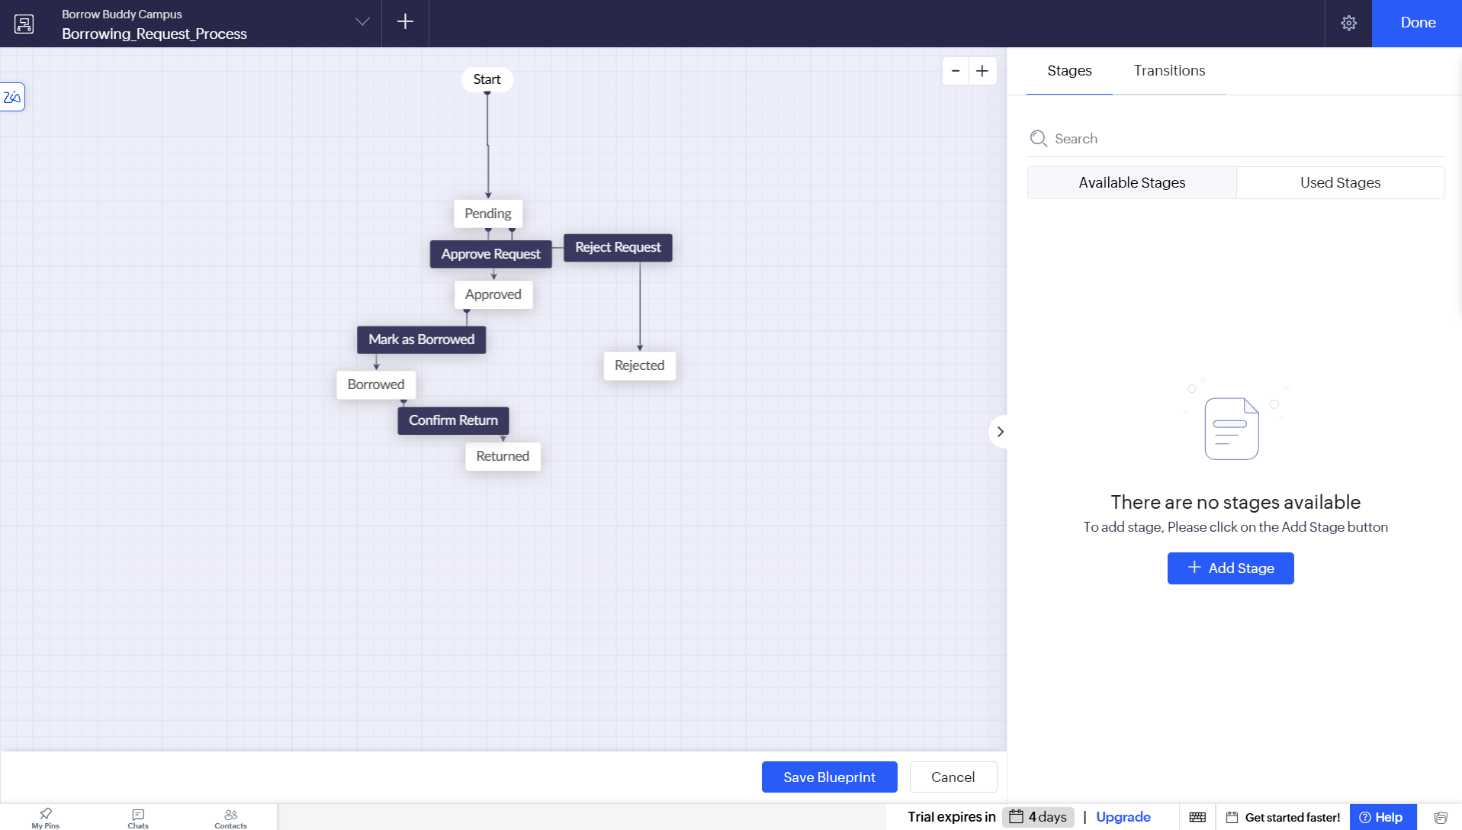
Figure 5.6: Borrowing Request Blueprint and Approval Configuration

5.7 Integrations

Table 5.4: Integrations Implemented
Integration | Service / Endpoint | Method | Authentication | Data Exchanged / Purpose
Zoho Mail | Zoho Mail | Connection not configured / verified | Not applicable | Email actions were configured; successful delivery not confirmed
Zoho Cliq | Zoho Cliq | Not configured | Not applicable | Proposed coordinator alerts
Zoho Calendar | Zoho Calendar | Not configured | Not applicable | Proposed return-date events

Code 5.3: [Integration script – replace with your own]
// External integrations were not implemented or verified in this project version.
// Zoho Mail, Cliq and Calendar connections remain future work.

5.8 User Management and Role-Based Access

User and permission settings include the Student Peer Coordinator and Student Borrower roles, together with an administrative role hierarchy. Portal user permissions were also opened and reviewed. The permissions page showed module-level access settings for Student Registration, Borrowing Request and Borrowing Feedback. The configuration should be reviewed against the final demonstration accounts before production use. Access should be granted only to the modules required by each role.

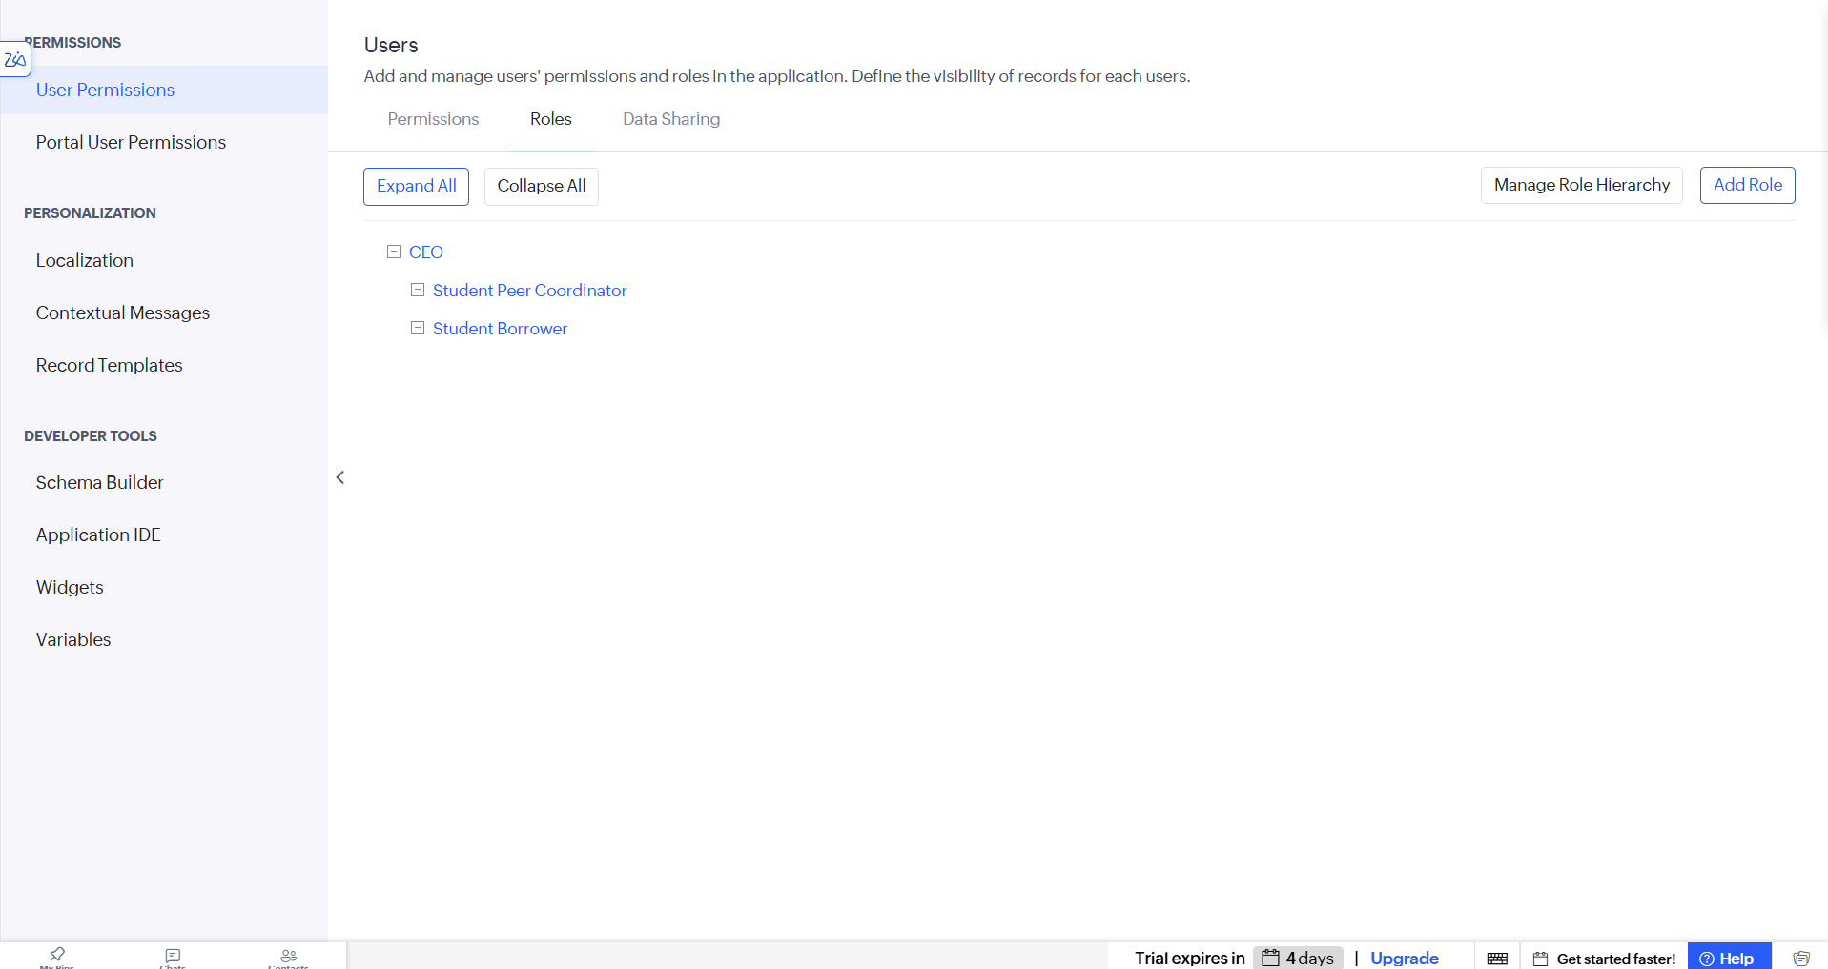
Figure 5.8: Roles and Permission Profiles Configuration

5.9 AI and Analytics Features

The dashboard includes an AI Suggested Urgency summary area and request analytics charts. These provide a place to display urgency-related information and monitor request distribution. However, the separate AI model named Urgency_Classifier, its input/output mapping and its workflow execution were not verified as operational in the application. Therefore, the AI classifier is treated as a proposed enhancement rather than a completed AI integration.

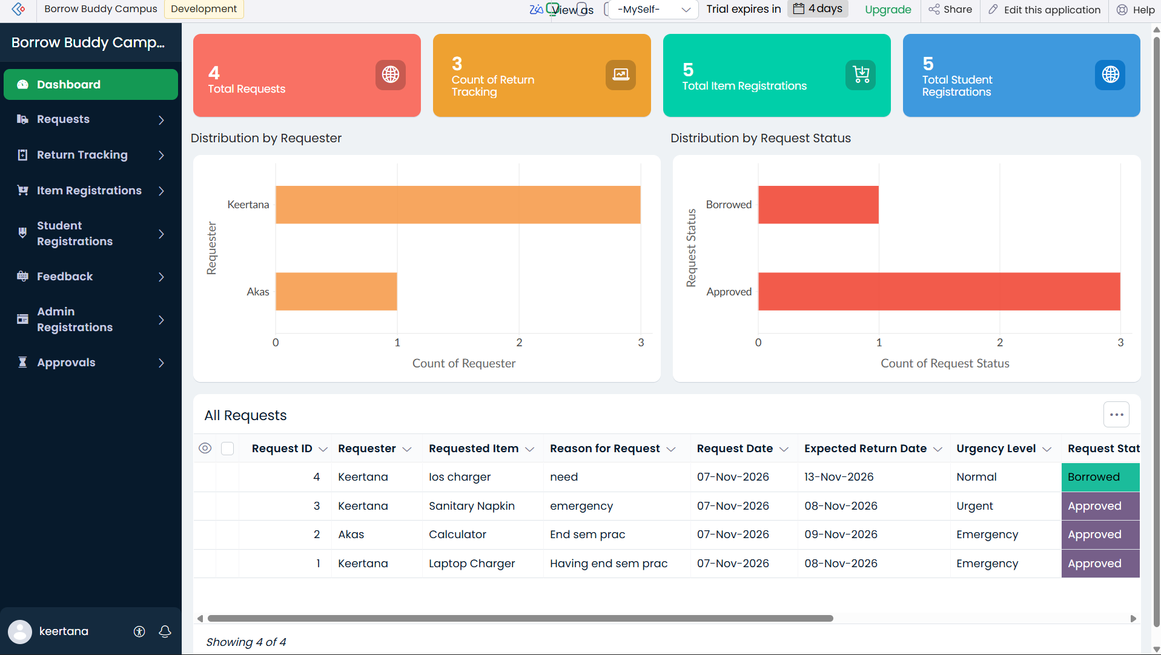
Figure 5.9: Dashboard Analytics and AI Suggested Urgency Area

5.10 Pro-Code Extension

No separate pro-code extension using Zoho Catalyst, custom JavaScript widgets or Creator REST APIs was implemented in this version. The application was developed using Zoho Creator’s visual builders and Deluge scripting. A future version could use a custom API or microservice if more complex processing or external-system integration is required.
CHAPTER 6

TESTING AND DEBUGGING

6.1 Testing Strategy

Testing was performed using sample records and the available Zoho Creator development interface. Form and report visibility was checked, the dashboard was reviewed with sample data, the borrowing request status was changed, and the return-tracking workflow was tested. During the return test, a return record was added and the linked item availability changed to Available. Email delivery, external integrations, AI model execution and all role-specific user journeys were not independently verified.

6.2 Test Cases

Table 6.1: Test Cases
TC ID | FR Ref. | Test Description | Input / Steps | Expected Result | Actual Result | Status
TC-01 | FR-01 | Register a student | Enter student details and submit | Student record is saved | Student registration form/report available | Pass (basic)
TC-02 | FR-02 | Register an item | Enter item name and Available status | Item record is saved | Item records visible in application | Pass (basic)
TC-03 | FR-03 | Submit borrowing request | Select requester and requested item | Request record is created | Request records visible in All Requests | Pass (basic)
TC-04 | FR-04 | Review approval configuration | Open approval workflow | Coordinator is listed as approver | Borrowing_Request_Approval enabled | Pass (configuration)
TC-05 | FR-05 | Record item return | Add Return Tracking record | Related item becomes Available | Availability changed to Available | Pass

6.3 Debugging Deluge Scripts

Debugging involved checking the Deluge editor’s validation messages, correcting form link names and field references, and testing functions with sample arguments. One issue occurred when an incorrect variable name was used in a workflow email expression; the expression was revised to refer to the form input and the related student registration record. Form link names such as student_registration, item_registration and borrowing_request were used consistently in the corrected scripts.

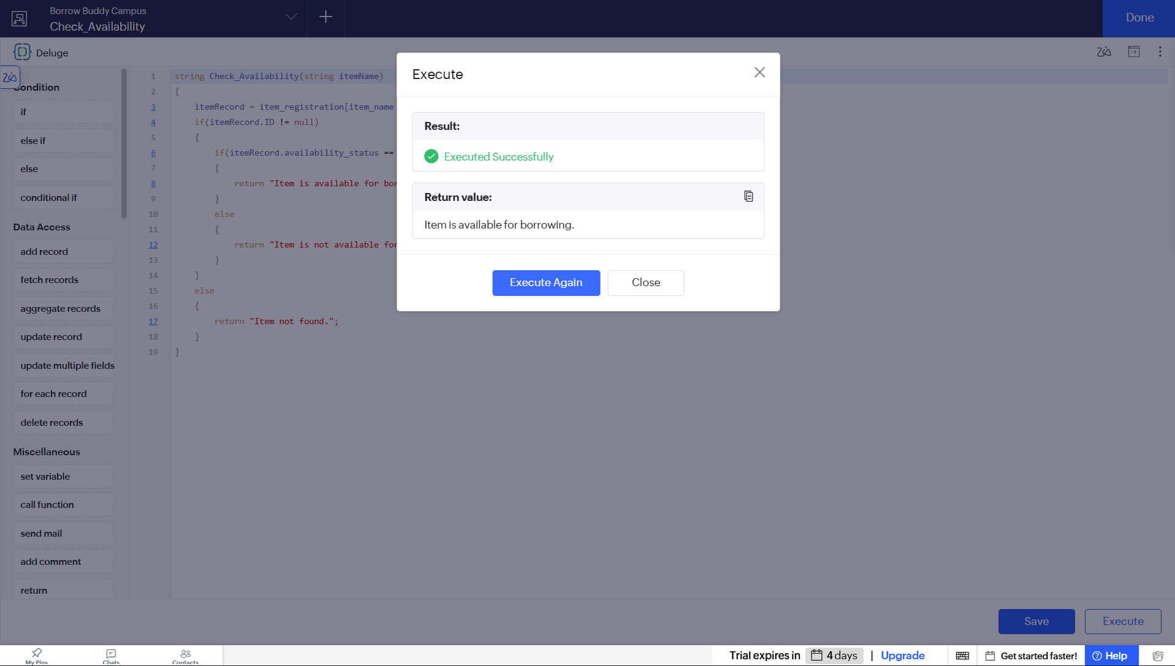
Figure 6.1: Deluge Debugging and Function Test Output

6.4 Defect Log
Table 6.2: Defect Log
Bug ID | Description | Root Cause | Fix Applied | Status
BUG-01 | Workflow email expression referenced an undefined variable. | Incorrect variable name in workflow context. | Changed expression to use input and the related student_registration record. | Corrected; email delivery not verified
BUG-02 | Item availability did not update automatically on return. | Return workflow needed to fetch the related request and item. | Added Deluge logic to update item_registration.availability_status to Available. | Closed; tested

6.5 User Acceptance Testing

Table 6.3: User Acceptance Feedback
User | Role Tested | Feedback | Action Taken
Project developer | Administrator / builder | Dashboard and forms provide a single place to view sample borrowing data. | Reviewed dashboard and form navigation.
Sample coordinator scenario | Student Peer Coordinator | Return tracking should update the item availability. | Verified return workflow changes item status to Available.
CHAPTER 7

DEPLOYMENT, SECURITY AND GOVERNANCE

7.1 Environments and Deployment Strategy

The application was created and configured in the Zoho Creator development environment. The project was tested with sample data in the application builder. A separate production deployment and public URL verification were not confirmed at the time of report preparation. Before production use, the administrator should verify roles, permissions, connections, workflows, sample data and the published application URL.

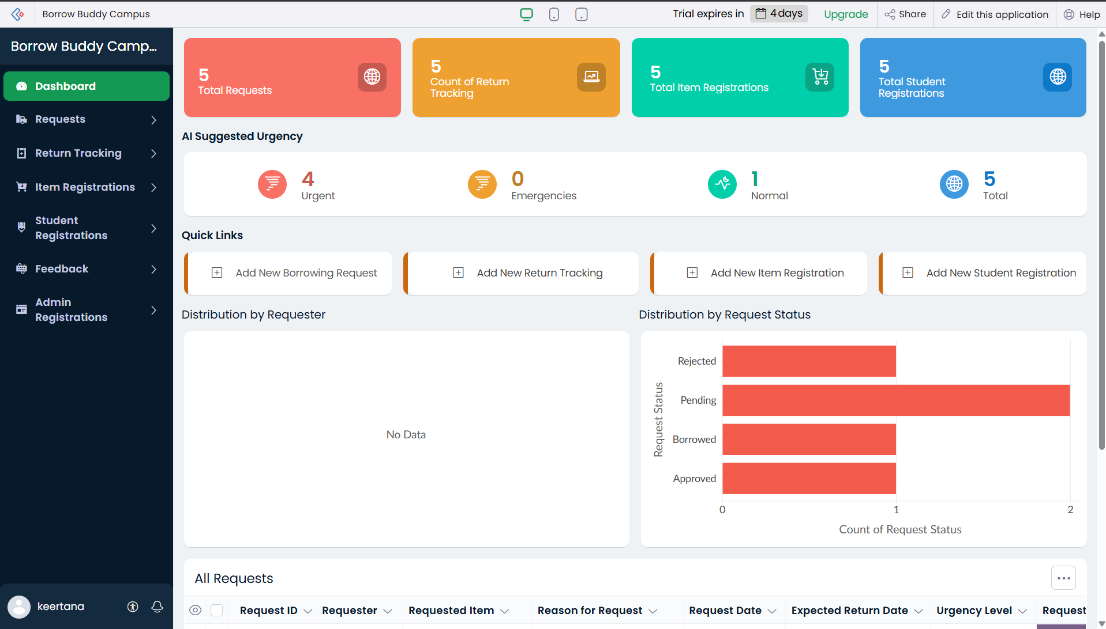
Figure 7.1: Development Environment and Deployment Status
Table 7.1: Deployment Checklist
S.No. | Checklist Item | Done (✓)
1 | Forms, reports and dashboard reviewed in development environment | ✓
2 | Sample/test data removed or isolated | Not completed
3 | Roles and permissions configured/reviewed | Partially
4 | Connections authorised in production | No
5 | Approval, Blueprint and return workflow enabled | ✓
6 | Production application URL verified | No
7 | Version / release notes recorded | No

7.2 Performance Optimisation

Table 7.2: Performance Optimisation Results
Optimisation Applied | Component | Before | After | Improvement
[Replaced fetch inside loop with single criteria fetch] | [DS-03] | [ ] | [ ] | [ ]
[Filtered report by default criteria] | [All Orders report] | [ ] | [ ] | [ ]
[ ] | [ ] | [ ] | [ ] | [ ]

7.3 Security Features

Table 7.3: Security Controls Implemented
Security Control | Where Applied | Threat Mitigated
Role permissions | Settings → User Permissions / Roles | Unnecessary module access
Portal permissions | Settings → Portal User Permissions | Uncontrolled portal module access; final access test pending
Workflow and lookup validation | Borrowing Request and Return Tracking | Incorrect record association and availability updates
OAuth connection | No external connection verified | External credential exposure; integration not enabled

7.4 Governance and Administration

Governance for the current prototype consists of maintaining consistent form and field link names, limiting user permissions to required modules, reviewing workflow configuration and testing changes with sample records. A production backup, formal release log and periodic audit process should be established before the application is used for real campus operations.

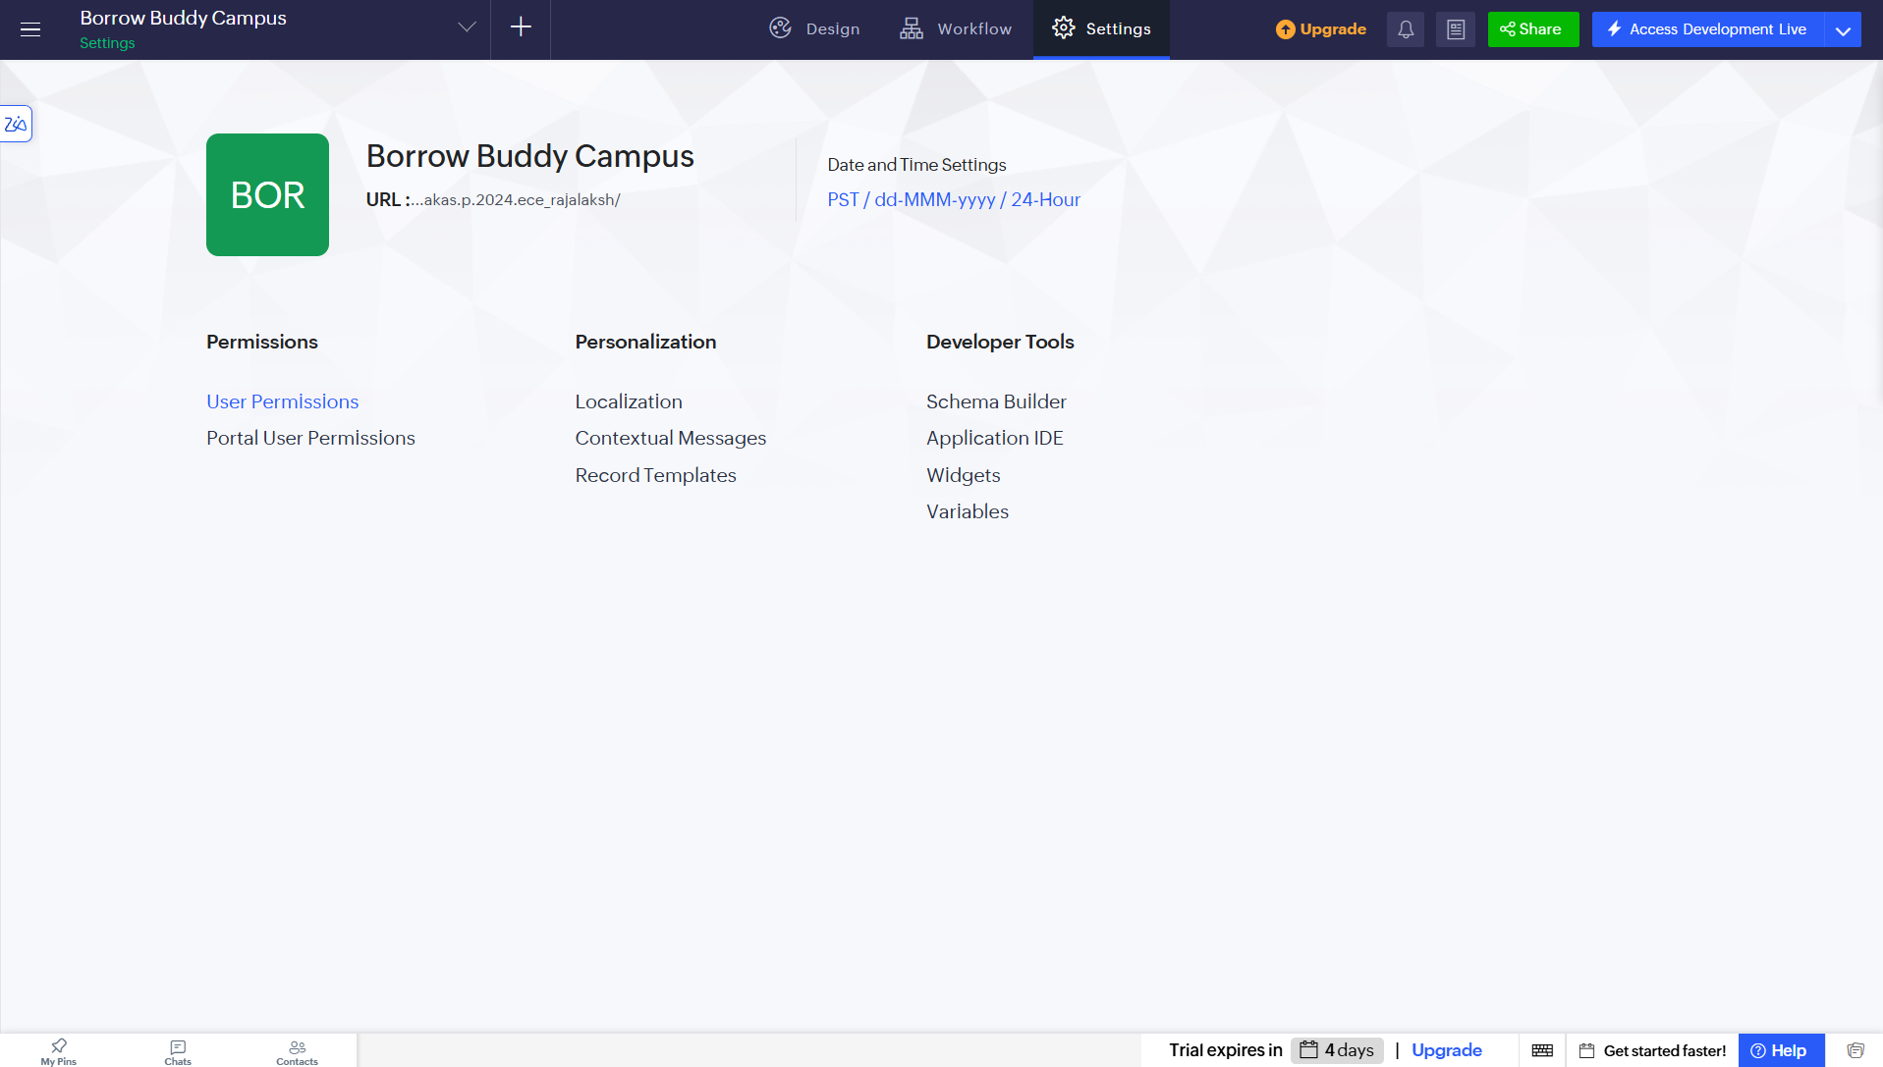
Figure 7.2: Administration and Permission Settings
CHAPTER 8

RESULTS AND DISCUSSION

8.1 Application Output

A student is registered in the Student Registration form. The coordinator adds available campus resources through Item Registration. The student submits a Borrowing Request by selecting the requested item. The request is reviewed through the configured approval workflow and represented in the Borrowing_Request_Process Blueprint. Once the item is issued, its status can be maintained through the borrowing lifecycle. When the student returns the item, a Return Tracking record is added. The tested return workflow locates the associated borrowing request and item and changes the item availability to Available. Feedback can then be recorded in Borrowing Feedback.

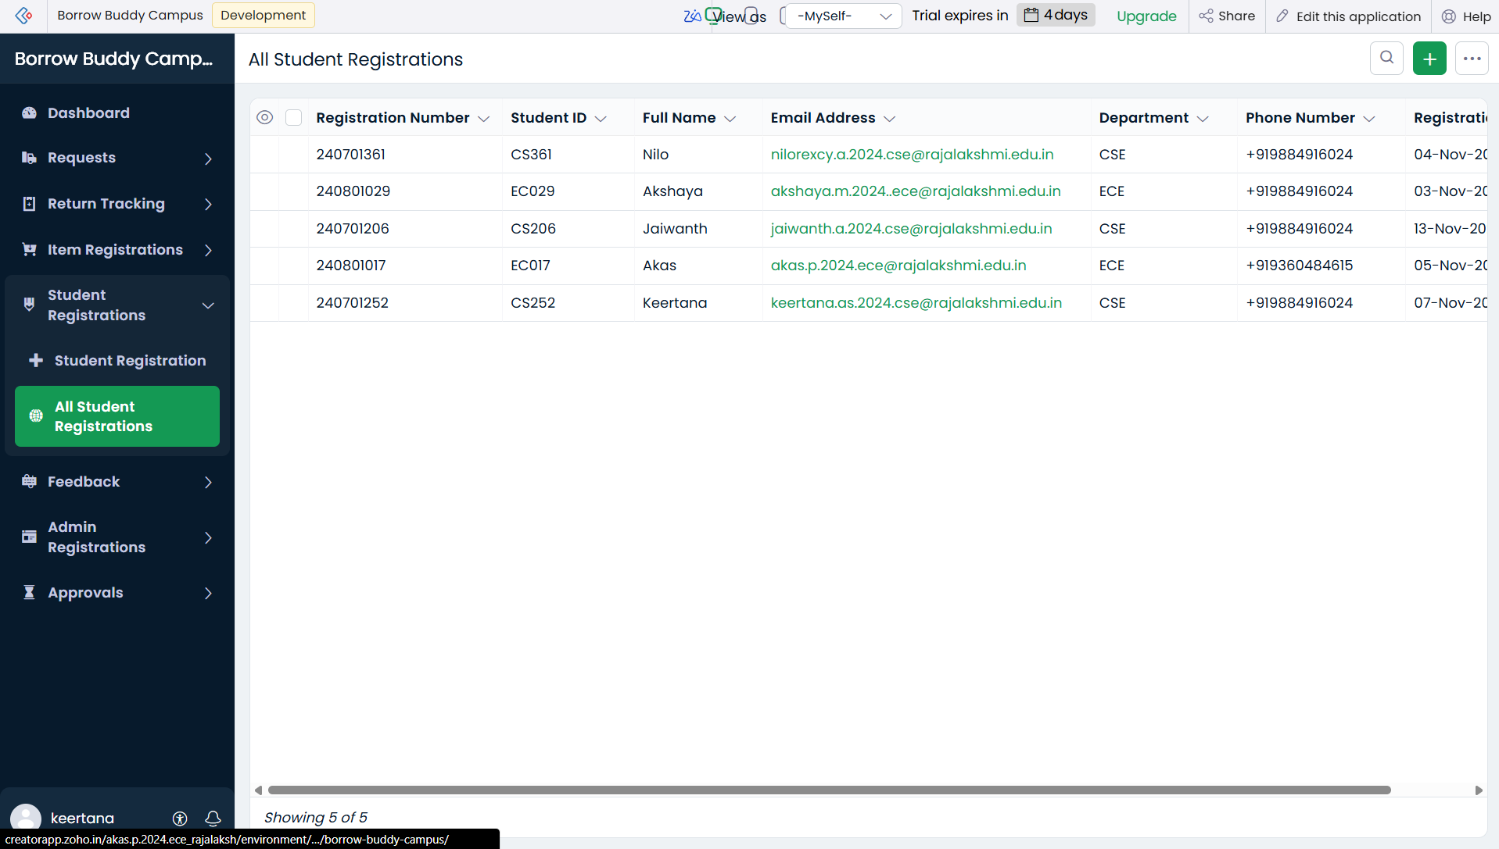
Figure 8.1: Student Registration and Item Catalogue

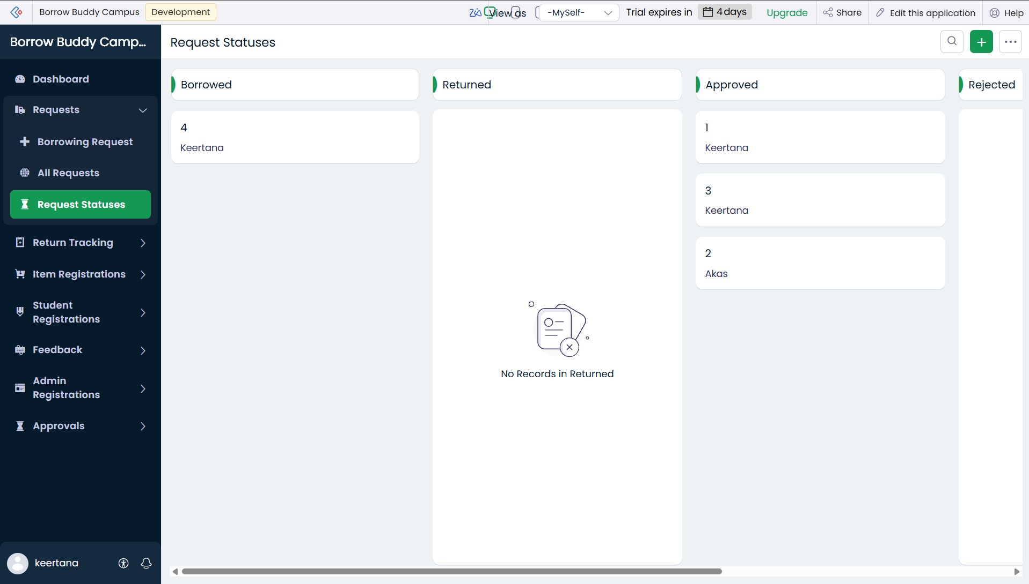
Figure 8.2: Borrowing Request and Coordinator Approval

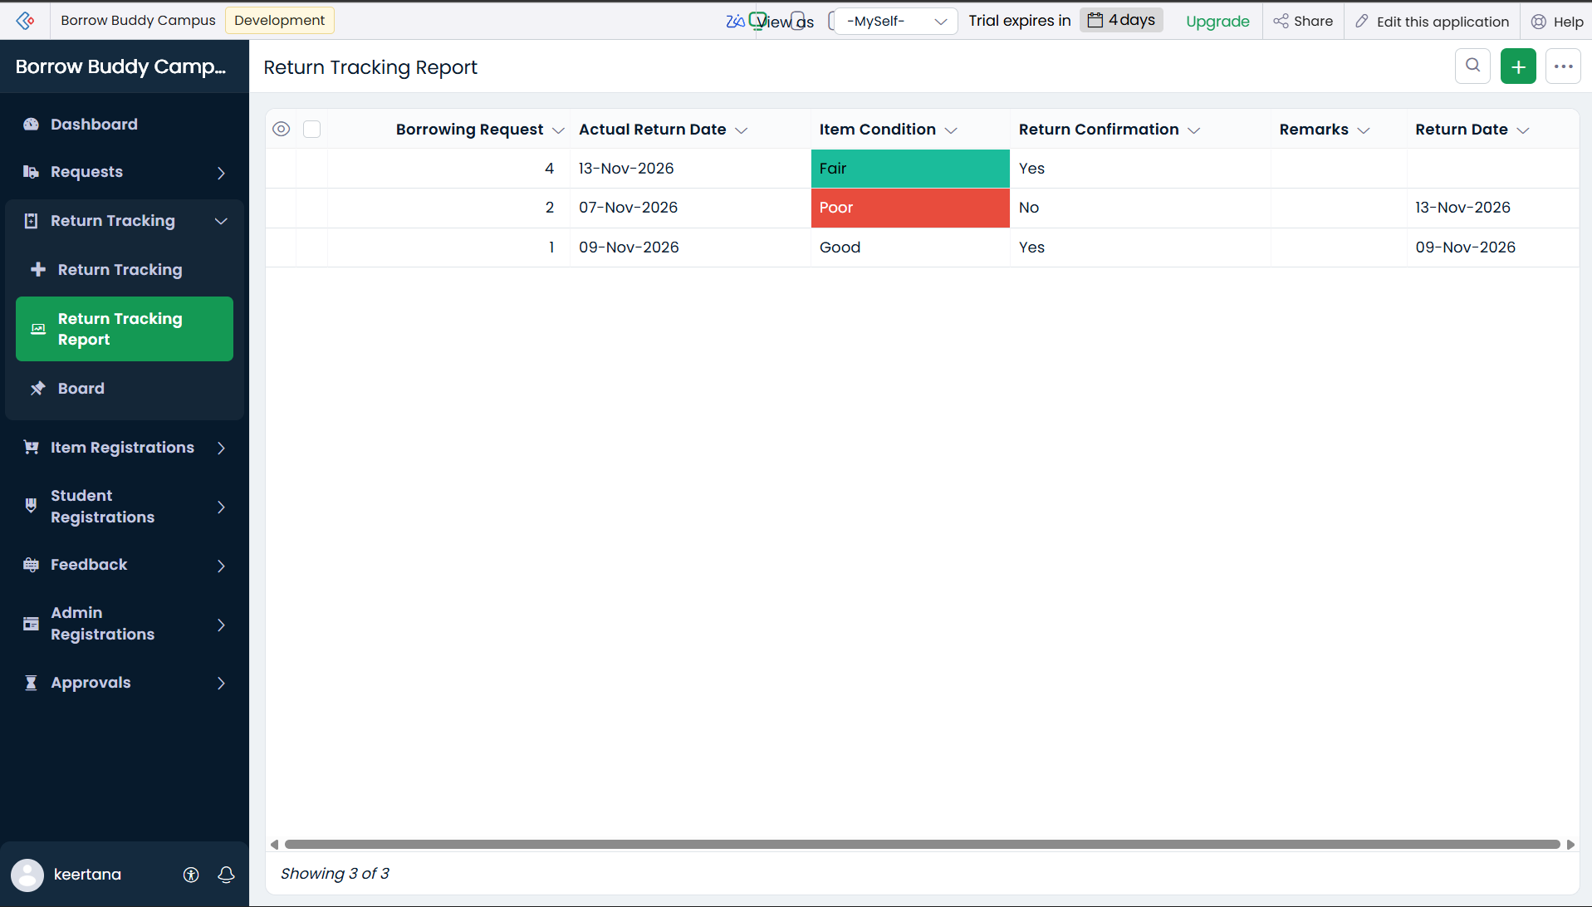
Figure 8.3: Return Tracking and Item Availability Update

8.2 Achievement of Objectives
Table 8.1: Mapping of Objectives to Outcomes
Objective (Sec. 1.3) | Implemented Through | Outcome / Evidence
Structured campus borrowing records | Student Registration, Item Registration, Borrowing Request, Return Tracking, Borrowing Feedback | Five core forms created
Automate request and return handling | Deluge functions, approval workflow, Blueprint and return workflow | Return workflow verified to update item availability
Provide monitoring and reports | All Requests and dashboard | Summary counts and request distribution charts displayed

8.3 Comparison with the Existing System
Table 8.2: Existing System versus Proposed Application
Parameter | Existing System | Proposed Application | Improvement
Request tracking | Messages / paper / separate records | Central Borrowing Request form and All Requests report | Centralised status visibility
Manual steps | Coordinator checks and updates records manually | Selected checks and return update automated | Reduced repeated record updates
Report generation | Manual counting and compilation | Dashboard counts and charts | Faster overview of sample data
Data accessibility | Records may be held by individuals | Central Zoho Creator application | Shared structured records subject to permissions

8.4 Limitations of the Low-Code Approach

The project is constrained by the capabilities and configuration options available in the selected Zoho Creator environment. Some advanced functions require additional testing, user accounts or authorised service connections. External integrations and the AI urgency classifier were not verified. Portal permission settings were inspected, but a complete student portal sign-in journey was not demonstrated. The application also depends on correct lookup relationships and field link names; a mismatch can cause Deluge scripts to fail. These limitations can be addressed through further testing, connection setup and controlled deployment.

8.5 Reflection on the No-Code → Low-Code → Pro-Code Spectrum

The application uses no-code features for form layout, report creation, dashboard components, role configuration, Blueprint stages and approval setup. It uses low-code Deluge scripting for validation, availability checks and return automation. A pro-code extension would be required only if future requirements exceed the built-in Creator capabilities, such as a dedicated external service or a custom interface component.
CHAPTER 9

CONCLUSION AND FUTURE ENHANCEMENTS

9.1 Conclusion

Borrow Buddy Campus demonstrates a centralised approach to managing short-term borrowing of campus resources. It includes student and item registration, borrowing requests, return tracking, feedback, reports and a dashboard. The request lifecycle is represented through a Blueprint and an approval workflow, while Deluge functions provide supporting logic. The return workflow was tested and successfully updated the availability of the associated item to Available. The project meets its core objective of organising campus borrowing records and improving visibility of item status.

9.2 Future Enhancements
- Integration with Zoho Mail, Cliq and Calendar to send notifications and create return reminders after the required connections are authorised.
- Implement and test the Urgency_Classifier AI model to classify borrowing requests and display the result to coordinators.
- Extend the portal and role-based access model, add overdue schedules and deploy a verified production version for campus-wide use.

9.3 Learning Outcomes and Career Relevance

Developing this application provided practical experience in data modelling, form and report creation, Deluge scripting, workflow configuration, Blueprint design, approval processes and role-based permissions. These skills are relevant to low-code application development, business process automation and software analysis. The project also highlighted the importance of testing generated configurations and documenting the difference between configured, tested and proposed features.

REFERENCES

[1] Zoho Corporation, “Zoho Creator Help Documentation.” [Online]. Available: https://www.zoho.com/creator/help/ (Accessed: 09 Nov. 2026).
[2] Zoho Corporation, “Deluge Script Reference Guide.” [Online]. Available: https://www.zoho.com/deluge/ (Accessed: 09 Nov. 2026).
[3] Zoho Corporation, “Zoho Creator – Forms, Reports and Workflows.” [Online]. Available: https://www.zoho.com/creator/ (Accessed: 09 Nov. 2026).
[4] W. Rosam and O. Kalnichevski, Low-Code Development: A Practical Guide. New Delhi, India: BPB Publications.
[5] Gartner, Inc., “Magic Quadrant for Enterprise Low-Code Application Platforms,” Gartner Research. [Online]. Available: https://www.gartner.com/ (Accessed: 09 Nov. 2026).
[6] Zoho Corporation, “Deluge Documentation – Functions and Tasks.” [Online]. Available: https://www.zoho.com/deluge/help/ (Accessed: 09 Nov. 2026).
[7] Zoho Corporation, “Zoho Creator Learning Resources.” [Online]. Available: https://www.zoho.com/creator/resources/ (Accessed: 09 Nov. 2026).

APPENDIX A – ZOHO CREATOR FEATURE COVERAGE CHECKLIST

Table A.1: Feature Coverage Checklist
Unit | Zoho Creator Feature | Done | Where in the Application | Report Section | Figure / Code No.
I | Application created & sections/menu organised | Y | Borrow Buddy Campus | 5.1 | Fig. 5.1
II | Forms with ≥ 8 distinct field types | Not verified | Five core forms; field-type count not audited | 5.2 | Fig. 5.2–5.3
II | Lookup field (relationship between forms) | Y | Borrowing Request / Return Tracking | 4.2, 5.2 | Table 4.1
II | Subform (parent–child data) | N / not verified | Not confirmed | 4.2, 5.2 | —
II | Field validations / layout rules | Partially | Student validation function created | 5.2, 5.5 | DS-02
II | List report with filter, grouping, custom action | Partially | All Requests | 5.3 | Fig. 5.4
II | Kanban / Calendar / Timeline / Map report | N / not verified | Not confirmed | 5.3 | —
II | Dashboard with charts and KPI panels | Y | Borrow Buddy Campus dashboard | 5.4 | Fig. 5.5
II | Deluge custom functions | Y (created) | 10 functions; not all independently tested | 5.5 | Table 5.2
II | Form workflows | Partially | Request notification and return update workflows | 5.6 | Table 5.3
II | Approval process | Y (configured) | Borrowing_Request_Approval | 5.6 | Fig. 5.6
II | Blueprint | Y (enabled) | Borrowing_Request_Process | 5.6 | Fig. 5.6
II | Scheduled workflows | Not verified | No schedule execution verified | 5.6 | —
II | Batch workflows | N / not verified | Not configured | 5.6 | —
III | User roles | Y | Student Peer Coordinator / Student Borrower | 5.8 | Fig. 5.8
III | Permission profiles | Partially | User and portal permissions reviewed | 5.8 | Fig. 5.8
III | Portal user access | Not verified | Portal permissions page inspected | 5.11 | Fig. 5.10
III | Zoho Mail integration | Not verified | Email action configured; connection/delivery not verified | 5.7 | Table 5.4
III | Zoho Cliq integration | N | Not configured | 5.7 | —
III | Zoho Calendar integration | N | Not configured | 5.7 | —
III | External API integration | N | Not implemented | 5.7 | —
III | AI model / Zia feature | Not verified | AI Suggested Urgency dashboard area only | 5.9 | Fig. 5.9
IV | Development environment | Y | Zoho Creator development builder | 7.1 | —
IV | Stage environment | N / not verified | Not used | 7.1 | —
IV | Production deployment | N / not verified | Not confirmed | 7.1 | —
IV | Performance optimisation | Basic | Criteria-based fetches in selected functions | 7.2 | —
IV | Security configuration | Partially | Role and portal permissions configured/reviewed | 7.3 | Table 7.3
IV | Audit trail | Not verified | Not demonstrated | 7.4 | —
V | Pro-code extension | N | No Catalyst / custom widget / REST extension | 5.10 | —
V | Mobile application | Not verified | Mobile use not demonstrated | 5.11 | —
V | User acceptance testing | Limited | Sample scenario reviewed; formal UAT not recorded | 6.5 | Table 6.3
V | Documentation and user manual | Y | This report and Appendix D | Appendix D | —

APPENDIX B – COURSE OUTCOME MAPPING

Table B.1: Mapping of Course Outcomes to Report Chapters
CO | Course Outcome Statement | Evidenced In | Self-Assessed Level | Examiner Level
CO1 | Explain principles, architecture and business value of low-code development. | Ch. 1, 2 | 3
CO2 | Develop business applications using forms, reports, workflows and Deluge. | Ch. 4, 5, 6 | 3
CO3 | Integrate applications with Zoho services and external systems. | Ch. 4.6, 5.7–5.9 | 1
CO4 | Deploy, secure and manage applications across environments. | Ch. 7 | 2
CO5 | Evaluate low-code strategies, AI-assisted building and the no-code/low-code/pro-code spectrum. | Ch. 5.9, 5.10, 8.4, 8.5, 9.3 | 2

APPENDIX C – COMPLETE DELUGE SOURCE CODE

C.1 [Form / Function Name]
// Script ID: DS-01 to DS-10
// Location: Zoho Creator custom functions
// Purpose: Request ID generation, student validation, item availability,
// pending status, return-day calculation, availability updates,
// average rating, overdue checking and emergency email logic.
// Paste the exact saved source from the Zoho Creator editor before final submission.

C.2 [Form / Function Name]
// Return Tracking form workflow – On Add
borrowingRecord = borrowing_request[ID == input.borrowing_request];
if(borrowingRecord != null)
{
itemRecord = item_registration[ID == borrowingRecord.requested_item];
if(itemRecord != null)
{
itemRecord.availability_status = "Available";
}
}

APPENDIX D – USER MANUAL

D.1 Accessing the Application
1. Open the Borrow Buddy Campus application using the authorised application URL. 2. Sign in with the account assigned by the administrator. 3. Use the application navigation to open the required form or report. 4. Do not share login credentials.

D.2 Instructions for Student Borrower
- 1. Complete Student Registration with the required student details. 2. Open the item catalogue and identify the required item. 3. Submit a Borrowing Request and monitor its status through the available request report.
- 4. Return the borrowed item through the return process as instructed by the coordinator. 5. Submit feedback after the borrowing process is complete.

D.3 Instructions for Student Peer Coordinator
- 1. Open All Requests and review new Pending requests. 2. Use the approval process to approve or reject the request.
- 3. Maintain item records and availability. 4. Record returns using Return Tracking and verify that the item availability becomes Available. 5. Review dashboard counts and feedback records.

APPENDIX E – EVALUATION RUBRIC
(For Examiner Use Only)

Student Name | Keertana A S | Register No. | 240701252
Project Title | Borrow Buddy Campus | Date | November 2026

Table E.1: Evaluation Rubric for the Individual Project
S.No. | Criterion | Indicators | Max. Marks | Marks Awarded
1 | Problem Definition & Requirement Analysis | Clarity of problem, measurable objectives, complete FR/NFR, use cases | 10
2 | System Design | Architecture, ER/data model, form specifications, workflow design, permission matrix | 10
3 | Forms, Reports & Pages | Variety of field types, lookups/subforms, report types, UI Builder dashboards | 15
4 | Deluge Scripting & Workflows | Correctness and depth of scripts; form, schedule, approval, Blueprint, batch workflows | 15
5 | Integration, RBAC & AI | Zoho/external integrations, connections, roles & permissions, Zia/analytics | 10
6 | Testing, Deployment, Security & Governance | Test coverage, environments, optimisation, security controls, audit | 10
7 | Live Demonstration | End-to-end working of the application across roles; feature checklist verified | 15
8 | Project Report | Adherence to template and format, clarity, figures, references | 5
9 | Viva-Voce | Understanding of the platform, design decisions and low-code concepts | 10
 | TOTAL |  | 100

Table E.2: Performance Level Descriptors
Level | % of Max. Marks | Descriptor
Excellent | 90–100 | Feature implemented completely, correctly and beyond the basic requirement; student explains design choices confidently.
Good | 70–89 | Feature implemented correctly with minor gaps; explanation adequate.
Satisfactory | 50–69 | Feature partially implemented or works only for the main path; limited explanation.
Needs Improvement | < 50 | Feature missing, non-functional or not understood by the student.

Signature of Internal Examiner  Name: ____________________ | Signature of External Examiner  Name: ____________________

APPENDIX F – VIVA-VOCE RECORD SHEET
(For Examiner Use Only)
Student Name | [ ] | Register No. | [ ]
Department / Section | [ ] | Date of Viva | [ ]
Application URL Verified | Yes / No | Demo Duration | ______ min
Table F.1: Viva-Voce Questions and Responses
Q.No. | Question / Topic Asked | Unit | Response (E / G / S / NI) | Remarks
1
2
3
4
5
6
7
8
E – Excellent G – Good S – Satisfactory NI – Needs Improvement
Table F.2: Marks Summary
Component | Max. Marks | Marks Awarded
Criteria 1–8 (Appendix E) | 90
Viva-Voce | 10
TOTAL | 100

Examiners’ Remarks:
____________________________________________________________________
____________________________________________________________________
INTERNAL EXAMINER  Name: ____________________ | EXTERNAL EXAMINER  Name: ____________________

